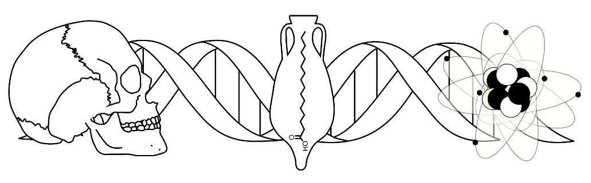
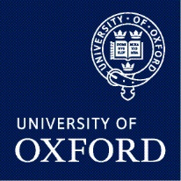

Bioarchaeology Seminar Series
Trinity Term 2022
Mondays, 12:00-13:00, In-person (SPR 1, LT) and streamed via Microsoft Teams
Teams link for all sessions:
https://teams.microsoft.com/l/meetup-join/19%3a4890e8bbbb9e4dbd88981685cd341334%40thread.tacv2/1631807090903?context=%7b%22Tid%22%3a%22cc95de1b-97f5-4f93-b4ba-fe68b852cf91%22%2c%22Oid%22%3a%22e28d8f0f-7378-413e-8e24-931e77b8c497%22%7d

Week 1 – 25 April
Marion Davidson, PhD student, University College London
“Ancestry Estimation in Forensic Anthropology: Preferences, Practices, and Future Considerations”

Week 2 – 2 May (Bank Holiday)
No Speaker

Week 3 – 9 May
Maura Griffith, PhD Student, University College London
“No Bones About It: Dental Approaches to Juvenile Sex Estimation”

Week 4 – 16 May (Online Seminar)
Dr. Jess Emma Thompson, Research Associate, University of Cambridge
“Making Ancestors: Deathways and Inequality in Prehistoric Europe”

Week 5 – 23 May
Jasmine Lundy, PhD Student, University of York
“Pots, people and past culinary habits: organic residue analysis of ancient ceramic containers”

Week 6 – 30 May
No Speaker

Week 7 – 06 June
Dr John Meadows, Senior Scientist, Kiel University
“Reliable dates from unreliable materials? Tools for improving the absolute chronology of prehistoric northeastern Europe”

Week 8 – 13 June
Dr Mélanie Roffet-Salque, Royal Society Dorothy Hodgkin Fellow, University of Bristol
“TBD”

For more information or to subscribe to the mailing list please contact Michael Scott (michael.scott@arch.ox.ac.uk) or Corrie Hyland (corrie.hyland@hertford.ox.ac.uk)

