Medieval Archaeology Seminar
Trinity Term 2021
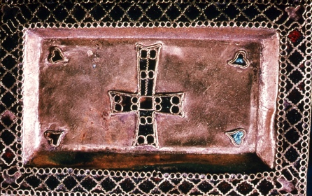
Mondays, 3.00

Teams link:
https://teams.microsoft.com/l/channel/19%3a804090b0492c409894015b7a6c6bba7f%40thread.tacv2/Medieval%2520Archaeology%2520Seminar?groupId=550fb0dc-672f-428e-81c4-e3d5e5f63b47&tenantId=cc95de1b-97f5-4f93-b4ba-fe68b852cf91

Week 2 – (3 May) Dr Emma Brownlee (Cambridge University)
Early Medieval bed burials: a European perspective

Convenors: J. Kershaw/ H Hamerow

