**Medieval Archaeology Seminar**

# Hilary Term, 2025

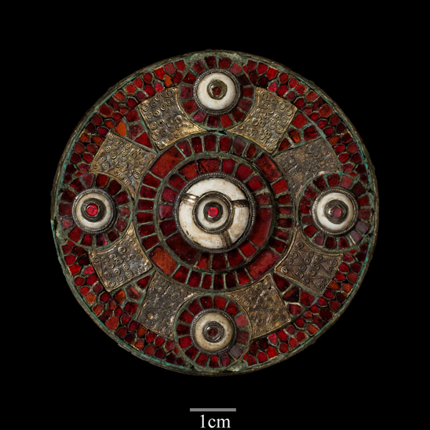

**Mondays 3.00, Institute of Archaeology, Lecture Room**

**Wk 2 (27 Jan) John Dinges.** *Moulding Emotions: Later medieval badges in England and Wales.*

**+ Caroline Croasdaile.** *Portable Reliquaries? English Late Medieval Containment Jewellery*

**Wk 4. (10 Feb) Wendy Scott.** *The Lenborough hoard*

**Wk 6 (24 Feb) Gabor Thomas, Roland Smith, Darko Maricevic.**

*Old Windsor: A reassessment*

**Wk 7 (3 March) Helena Hamerow.** *Feeding Medieval England: A long ‘agricultural revolution’*

*Convenors: H. Hamerow/J. Kershaw*