Medieval Archaeology Seminar

Hilary Term, 2026
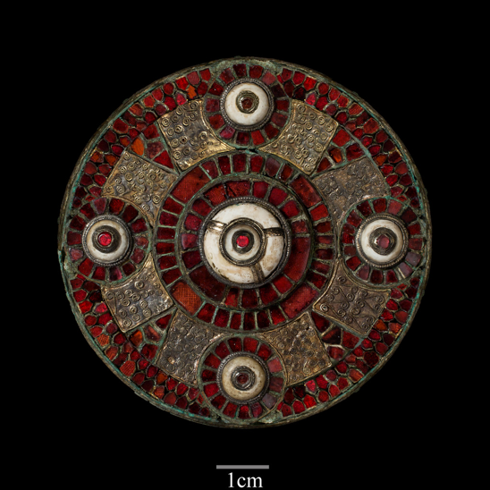
Mondays 3.00, Institute of Archaeology, Lecture Room

Week 2, 26 Jan. Jennifer Coulton. Structural Depositions, Haunted Houses, and Domestic Protection in England c.800-1250

Week 4, 9 Feb. Matthew Johnson. New World Settlement and the English Middle Ages

Week 6, 23 Feb. Charlotte Wood. Early medieval ‘liturgical combs’

Week 8, 9 March. Eugene Costello. Exploring the expansion of pastoral farming in northern Europe's uplands, c.1200-1600

