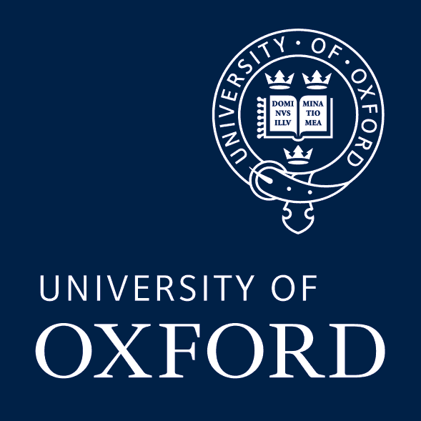

THE ROMAN DISCUSSION FORUM
MICHAELMAS Term 2025

Week 1  October 15 | Research Resources for Roman (and Other) Archaeologists  Professor Andrew Wilson, All Souls College
Week 2  October 22 | Recent Work at Iuvanum (Abruzzo), and Some Thoughts on Urbanism in the Uplands of Central Italy.  Dr Ed Bispham, Brasenose College
Week 3  October 29 | Modelling Agricultural Output in the Ager Cordubensis  Alvaro Soto, Kellogg College
Week 4  November 5 | “Un’altra testimonianza del favore” ― Can We Really Speak of a  Severan Africa?  Marie Wittmann, Lincoln College
Week 5  November 12 | Mauretanian Royal Statuary  Zoé Lienard, Merton College
Week 6  November 19 | Between the Tesserae: Reconstructing an Ancient Mosaic Assemblage in Roman North Africa  Vianne Storrs, St Anne’s College
Week 7  November 26 | An Untapped Resource: The Political, Cultural, and Economic Value of Cuniculi in Central Italy  Christina Monroe, Somerville College
Week 8  December 3 | Title TBC  Dr Jacqueline Ortoleva, School of Archaeology

Wednesdays at 1:00 PM
Followed by discussion and light refreshments

Lecture Room
Institute of Archaeology
36 Beaumont Street

Organisers: Andrew Wilson, Maria Tzeli, and Marie Wittmann
with the support of the Faculty of Classics, the School of Archaeology,
and All Souls College

